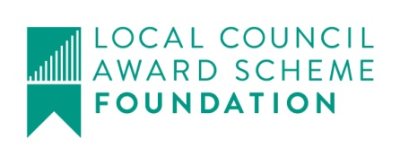
Harby Parish Council
01636 893342

Clerk@HarbyParishCouncil.gov.uk

www.HarbyParishCouncil.gov.uk

Clerk: Caron Ballantyne 21 August 2025

NOTICE OF ORDINARY MEETING OF HARBY PARISH COUNCIL
I hereby give you notice that the Parish Council Meeting will be held at HARBY VILLAGE HALL, High Street, Harby , NG23 7EW, in the Committee Room on THURSDAY 28 August 2025 at 19:30.

Meeting Ref: 210/25
- Declaration of intent to record, film or photograph the meeting by members, members of the public or the press
- Apologies for absence
- Declarations of interest (in accordance with the Local Government Act 2000)
- 10 minute parishioner time (members of the public may ask questions or make statements. Items not on the agenda cannot be debated but may be added to the next meeting)
- To
  - Approve the minutes of meeting: 209/25 Ordinary Meeting held on 3 July 2025.
- Planning
  - Applications -
25/00887/HOUSE | The Paddocks High Street | Porch extension with apex roof and trapezoid gable glazing
  - Decisions -
25/00269/FUL | Land At Holly House, Church Road | Granted
25/00630/S73M | Land At Station Road | Refuse
- Finance
- To receive bank reconciliation for July
- Payments since last meeting for approval
- Receipts since last meeting
- Payments for approval
- To consider gift to resident who has undertaken the refurbishment of the Railway Sign, under General Power of Competence
- To consider Virtual Land line for Parish Clerk
- To consider NALC training and opportunities for Clerks and Councillors
- Clerks and Councillors Reports
- Correspondence
- One Earth Solar Farm, Correspondence from South Clifton and the Planning Inspectorate
Signed Clerk: Caron Ballantyne

