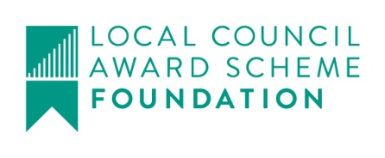
Bv Harby Parish Council
?

Clerk@HarbyParishCouncil.gov.uk

www.HarbyParishCouncil.gov.uk

Clerk: Yvonne Colverson 13 February 2026

NOTICE OF ORDINARY MEETING OF HARBY PARISH COUNCIL
I hereby give you notice that the Parish Council Meeting will be held at HARBY VILLAGE HALL. High Street, Harby, NG23 7EW, in the Committee Room on THURSDAY 23 October 2025 at 19:30.

Meeting Ref: 211/25
- Declaration of intent to record, film or photograph the meeting by members, members of the public or the press
- Apologies for absence
- Declarations of interest (in accordance with the Local Government Act 2000)
- 10 minute parishioner time (members of the public may ask questions or make statements. Items not on the agenda cannot be debated but may be added to the next meeting)
- To
  - Approve the minutes of meeting: 210/25 Ordinary Meeting held on 28 August 2025.
- Planning
  - Applications –
Application No | 25/01701/PIP
Date Registered | 6 October 2025
Proposal | Application for permission in principle for a residential development of up to 8 dwellings
Location | Land Off Enfield Court Harby Nottinghamshire
Q Code | Q13 Minor Dwellings
Case Officer | Kirsty Catlow - Telephone 01636 655346
Application website | https://publicaccess.newark-sherwooddc.gov.uk/online-applications/applicationDetails.do?activeTab=summary&keyVal=T3I2TOLB04M00

  - Decisions -
25/00918/S73 | 3 Sunnyside Cottage, High Street | Grant
25/0088/HOUSE | The Paddocks, High Street | Grant

- Finance
- To receive bank reconciliation for August and September
- Payments since last meeting for approval
- Receipts since last meeting
- Payments for approval
- To consider holding monies on behalf of the Trio following the death of the editor
- To review Parish Council website hosting
- Printer – to consider disposing of the parish council printer
- Clerks and Councillors Reports
- To consider annual tree survey report
- To consider draft Information Technology policy as required for Governance and Accountability Return
- Correspondence

- To consider date for annual walk about
Signed Clerk: Yvonne Colverson

