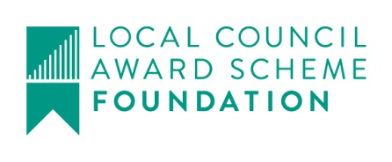
Harby Parish Council
?

Clerk@HarbyParishCouncil.gov.uk

www.HarbyParishCouncil.gov.uk

Clerk: Yvonne Colverson 12 February 2026
NOTICE OF ORDINARY MEETING OF HARBY PARISH COUNCIL
I hereby give you notice that the Parish Council Meeting will be held at HARBY VILLAGE HALL. High Street, Harby, NG23 7EW, in the Committee Room on THURSDAY 12th February 2026 at 19:30.

Meeting Ref: 213/25
- Declaration of intent to record, film or photograph the meeting by members, members of the public or the press
- Apologies for absence – To receive apologies for absence and approve if appr
3 Declaration of interests – To receive declarations of interests under consideration on this agenda in accordance with the Localism Act 2011 s.32 and The Relevant Authorities (Disclosable Petuniary Interests) Regulations 2012.

- 10 minute parishioner time (members of the public may ask questions or make statements. Items not on the agenda cannot be debated but may be added to the next meeting)
- Minutes of the previous meeting. To Approve the minutes of meeting: 212/25 Ordinary Meeting held on Thursday 18th December 2025.

- Planning
  - Applications
  - Decisions

- Finance
- To receive bank reconciliation for November and December 2025
- Payments since last meeting for approval
- Receipts since last meeting
- Payments for approval

- Clerks and Councillors Reports – To receive reports from the Clerk and Councillors, outlining actions since 18th December 2025
- Items for consideration

- Potholes – To consider and resolve actions that can be taken to resolve potholes in the village.
- Allotments – To consider and resolve the clearing of unused allotments, prior to new tenants having access

- Correspondence

