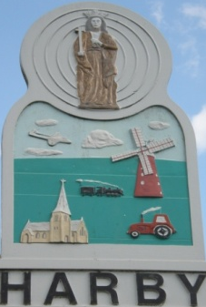
Harby Parish Council Risk Management Policy

Reviewed: 8th May 2025
Next Review: May 2026

Risks
This document has been produced to enable the Parish Council to assess the risks that it faces and satisfy itself that it has taken adequate steps to minimise them. The Council is aware that although risks cannot be eliminated fully, it has in place a strategy that provides a structured, systematic and focused approach to managing risk.

Risk is something that will affect the ability of the Council to achieve its objectives and meet its duties. Risk management is the process by which these risks are identified, evaluated and controlled. This document is reviewed at least annually.

Subject | Risk | Level of Risk | Management/Control of Risk | Actions
Council Records -  Paper | Loss through theft, fire or damage. | L | Archive material kept securely at village hall. Current working documents, minutes and accounts kept by clerk.  Historical documents copied by Harby History Group in 2013. | -
Council Records -  Electronic  IT | Loss through theft, fire, damage, virus.  Misuse | L | Electronic copies of documents kept on laptop. Online back-up of files occurs on a daily basis. Pertinent documents are shared with Cllrs and online ensuring they’re available in more than one place. Anti-virus software installed, operational and kept up to date. | Cloud back-up.  Ensure chairman has access to passwords in an emergency.
Financial planning | Adequacy of precept | M | An annual budget is set ensuring a sufficient precept to allow the council to achieve its objectives. A budget update is provided at each ordinary meeting. The full budget is set around December, based on past expenditure and the council’s objectives. The council also maintains reserves of around twice the amount of the annual precept. | Prepare Annual Budget and regularly review as per financial regulations,
Financial controls | Inadequate banking checks and financial controls.  Loss through theft.  Timely collection of income due. | L | The Council has Financial Regulations which set out the requirements for budgets, online/banking, cheques and reconciliation of accounts. This includes all income being paid into the bank. The necessity for petty cash has been removed. Accounts, reconciliations and receipts etc are reviewed and verified by two councillors on a monthly basis and annually by an internal auditor and reported online. The income due is listed on the budget, along with dates to ensure timely collection. Income is reviewed annually during the budget setting process. | Ensure income is collected by due date.  2 councillors to check bank reconciliations monthly.  Invoices to be signed by 2 councillors as approved
Election Costs | Costs when a full election takes place | L | Through the budgeting process the Council will consider this, however there are no measures available to minimise the risk of having a contested election. | Continue to hold between £300 - £400towards future election costs.
Assets | Loss or damage | M | An asset register is maintained and insurance is held at the appropriate level for all items. Regular checks are carried out on all assets and the Council undertakes an annual inspection of assets. Key land held by the Council has been registered with the Land Registry. | Complete registration of land on Church Rd.
Insurance | Adequacy | L | An annual review is undertaken of insurance arrangements.  Employers Liability, Public Liability and Fidelity Guarantee are a statutory requirement.  Clerk liaises with insurance company and Council to ensure the cover is appropriate and conditions are met to ensure compliance. | -
Insurance | Cost | L |  | -
Insurance | Compliance | M |  | -
Insurance | Fidelity Guarantee | L |  | -
Clerk | Loss of clerk | M | Key information and documents regularly shared with all Cllrs and key documents are posted online. All documents saved on the Council laptop and backed up online.
Clerk | Fraud | L | Ensure fidelity guarantee insurance adhered to. Ensure insurance requirements are met, including obtaining required references for clerk and signatories for insurance purposes. Council finances are audited regularly. | Obtain references for any new signatories and clerk
Member interests | Failing to disclose interests  Reputational damage | L | Members are required to disclose interests at the meeting and declare these on the interests form, as per regulations - failure to do so can result in a fine. | Members responsible for updating the register and declaring interests.
Actions undertaken | Ensuring decisions and actions are legal  Being sued | L | Clerk and Cllrs attend regular training, which is provided for in the budget. Council has access to support and information including on new legislation. Standing Orders and Financial Regulations govern council processes and are regularly reviewed to account for changes in law. Clerk to take further advice and check legality of decision if council is unsure. NALC membership is maintained. | Council to ensure any activities undertaken are covered by insurance.
Health and safety | Council activities | L | Meetings held in village hall which is considered adequate | Clerk and appropriate person(s) complete risk assessment. Council to ensure any activities undertaken are covered by insurance.
Health and safety | Liability | M | Risk assessments to be carried out for any new activities and events, as per the council’s Financial Regulations. Public liability insurance is held. | Complete Risk Assessment for defibrillators and allotments.
Trees on Council Land | Falling branch/tree injuring person/property | M | The council has in place a tree management plan, which includes an annual inspection of designated trees and is updated accordingly. Remedial work is carried out when required. If the land has tenants, they will be notified if work is required. | -
Allotment and field | Overgrown hedges impinging onto land | L | The council has in place a tree management plan, which includes an annual inspection of designated trees and the update is updated accordingly. Remedial work is carried out when required. If the land has tenants on, they will be notified if work is required. | -
Actions taken or not taken by the Council not being supported by the Community | Reputational damage | M | Council to consult and engage with the community before changing any services or commencing additional services and provide access to information regarding the Council’s activities. | Continue to keep the website up to date and provide updates through the Trio. Consult before making service changes.
Compliance with employment law | Reputational  Financial | M | Council to regularly review any new legislation and consider its implications | Clerk/councillors to undertake relevant training.
Bullying and Harassment | Individuals being victims | L | Councillors and clerk shall not attend meetings alone with member of the public. Any instances shall be recorded immediately and reported at the next Parish Council meeting.

*Risk is assessed based on likelihood and impact.

Appendix 1: Harby Parish Council Tree (and hedge) Management Plan

This plan has been developed following guidance in Common Sense Management of Trees by the National Tree Safety Group in order to help manage the risks associated with the trees which are on the Council’s Land. By law, the landowner on which a tree stands, has responsibilities for the health and safety of those on or near the land, and has potential liabilities arising from the falling of a tree or branch. The duty of care is to take reasonable steps to avoid acts or omissions that cause a reasonably foreseeable risk of injury to persons or property. Being reasonable involves taking actions proportionate to the risk. While the owner or manager may need to react to events involving dangerous trees as they arise, it is also prudent to have forward-looking procedures to keep tree-related risks at an acceptable level.

As recommended in the document referred to above, the areas with the Council’s trees on have been split into zones. In the high use zone (where the greatest risk is from trees within falling distance of where people move in vehicles) proactive and reactive management steps will be taken, to include a formal annual inspection. In the low use zone where there is infrequent public access, only reactive management will be undertaken.

Zone | Assessment Type
Medium Use Zone  Wigsley Road Allotments,  Jowetts Wood, Wigsley Rd  and Church Road sites | Proactive  Formal: The Council will carry out an annual ground level visual tree inspection on these sites, recording the findings in this document and schedule further assessments or arrange tree work accordingly.  Informal: Cllrs and the clerk will report any changes in tree condition if they see any during their day-to-day observations.  Reactive  Reports from members of the public will be investigated and acted upon.
Low Use Zone  Station Road Field site | Reactive  Reports from members of the public will be investigated and acted upon.

Tree inspection record: Last visual inspection Phil Thomas horticulturalist October 2025
No. | Location | Species | Height (m) | Condition | Comments
1 | Wigsley Rd ‘Green’ | Lime | 13 | 2025 Appears safe & in good order, one broken branch over hanging | 2024 Appears safe & good order, some epidermal growth  2023 Appears safe and in good order – remove epidermal growth  2022 Appears safe and in good order – remove epidermal growth  2021 Appear safe and in good order – remove epidermal growth  2020 Appears safe and in good order  2019 Lowest obstructive branches removed. Epidermal Growth minimal  2018 No work required  2017 Reduce branches by sign, epidermal growth removed from trunks/bases  2016 Crown lifting carried out. No work required.
2 | Wigsley Rd ‘Green’ | Lime | 13 | 2025 Appears safe & in good order | 2024 Appears safe & good order  2023 Appears safe and in good order  2022 Appears safe and in good order – Low branches obstructing path  2021 Appear safe and in good order – remove epidermal growth  2020 Appears safe and in good order  2019 Lowest obstructive branches removed  2018 No work required  2017 Epidermal growth removed from trunks/bases  2016 No work required.
3 | Wigsley Rd ‘Green’ | Lime | 15 | 2025 Appears safe & in good order | 2024 Appears safe & good order  2023 Appears safe and in good order  2022 Appears safe and in good order – needs trim of lower branches  2021 Appear safe and in good order  2020 Appears safe and in good order  2019 Lowest obstructive branches removed  2018 No work required  2017 Epidermal growth removed from trunks/bases  2016 No work required.
4 | Wigsley Rd ‘Green’ | Horse Chestnut | 16 | 2025 Appears safe & in good order | 2024 Appears safe & good order, little sign of leaf miner, good sign  2023 Appears safe and in good order – little sign of leaf miner, good sign  2022 Appears safe and in good order – lower branches require thining, suffers from leaf miner attack on lower canopy  2021 Appear safe and in good order – now touching village hall building  2020 Appears safe and in good order
5 | Wigsley Rd ‘Green’ | Walnut | 15 | 2025 Appears safe & in good order – could prune some dead lower branches | 2024 Appears safe & good order  2023 Appears safe and in good order  2022 Appears safe and in good order – some dead wood as always, remove  2021 Appear safe and in good order – Some branch die back, crown lift  2020 Appears safe and in good order  2019 Lowest obstructive branches removed  2018 No work required  2016 Branches crown lifted and cut back from near the village hall
6 | Wigsley Rd ‘Green’ | Silver Birch | 17 20 | 2025 Appears safe & in good order – height under estimated in past | 2024 Appears safe & good order  2023 Appears safe and in good order – heights under estimated in the past  2022 Appears safe and in good order – no work required  2021 Appears safe and in good order  2020 Appears safe and in good order  2019 No work required  2018 No work required  No work required.
8 | Wigsley Rd ‘Green’ | Silver Birch | 20 | 2025 Appears safe & in good order | 2024 Appears safe & good order  2023 Appears safe and in good order  2022 Appears safe and in good order  2021 Appears safe and in good order  2020 Appears safe and in good order  2019 No work required  2018 No work required  2016/17 Growing at angle and silver birches crowded – further investigation required – LS. Recommended to remove two trees – PT. Council agreed to remove tree (T7)
9 | Wigsley Rd ‘Green’ | Silver Birch | 20 | 2025 Appears safe & in good order | 2024 Appears safe & good order  2023 Appears safe and in good order  2022 Appears safe and in good order  2021 Appears safe and in good order 2021  2020 Appears safe and in good order 2020  2019 No work required 2019  2018 No work required 2018  No work required.
10 | Wigsley Rd ‘Green’ | Ash | 12 | 2025 Appears safe & in good order – no sign of ash dieback yet | 2024 Appears safe & good order  2023 Appears safe and in good order  2022 Appears safe and in good order – no work required  2021 Appears safe and in good order – no sign of die back  2020 Appears safe and in good order  2019 Lowest obstructive branches removed  2018 No work required  2016/17 Crown lifted
11 | Wigsley Rd ‘Green’ | Rowan | 7 | 2025 Appears safe & in good order. Little sign some new growth. Some dead wood, epidermal growth needs removing as well | 2024 Appears safe & good order  2023 Appears safe and in good order  2022 Appears safe and in good order  2021 Appears safe and in good order  2020 Appears safe and in good order  2019 No work required  2018 No work required  2017 Carried out removal of bottom growth  2016/17 Damage on one small branch, branch removed
12 | Church Rd | Horse Chestnut | 12 | 2025 Appears safe & in good order – healthy, little sign of leaf miner, a good looking tree | 2024 Appears safe & good order, little sign of leaf miner  2023 Appears safe and in good order – health, little sign of leaf miner  2022 Appears safe and in good order – no work required. Elder in corner requires cutting back  2021 Appears safe and in good order  2020 Appears safe and in good order  2019 No work required  2018 No work required.  2017 Tree in good condition  2016 No work required.  2016 Crown lifted to increase visibility of village information board and trimming back branches fouling overhead line
13 | Jowett’s Wood, Wigsley Rd | Including; Poplar, Beech ailanthus, Horse Chestnut, Silver Birch  Mixed hedge of Cherry, Snowberry Sumach | 20m 16m  17m  25m 22m  20m  20m 22m  2-4 m | 2025  16m – Now much reduced, appear safe  Appears safe & in good order  Appears safe & in good order  Appears safe & in good order  To be reduced some time soon  2025 Has now been trimmed back  2024 I have concern of the height so close to the road. Poplar, Silver Birch and Ailanthus to be reduced. Rowan now dead, to be cut up and left as rotting vegetation. Hedge has been trimmed back  2023 I have concerns about the height of the Poplar and Silver Birches so close to the road, both species should be reduced sometime soon. Rowan now dead, to be cut up and left as rotting vegetation. Hedging has been trimmed  2022 ivy on Silver Birch, stressed chestnut (13m), dead tree  2021  Trees appear safe and in good order – regrowth of topped poplar to be monitored. Hedge is safe condition – habitat for flora and fauna. Roe dear seen in wood  2020  Appears safe and in good order. Hedge has been trimmed and is safe. Some ivy growth on trees, which has been removed by tenants  2019  No work required  2018  One poplar has large loss of bark and having new growth will need felling at a future date – has been felled by tenant  One very tall poplar has a long split at lower part of trunk and will need to be monitored – has been felled by tenant  Hedge has been trimmed  2017  Not inspected  2016  Hedge has been trimmed.  Ash tree die back disease fell - PT  Pine tree on allotment boundary is leaning and recommended for felling – as per 2015  Cut back snowberry a vigorous spreading shrub  Bushes/vegetation alongside Wigsley Road continue to maintain to ensure visibility from junction and access along footpath.  2015  Required  One poplar on front road side boundary has died and requires felling (tenant) – completed.  Cut back overhanging branches near access road on two silver birches to a min. height of 3.7m (tenant)- completed.  Continue to maintain the hedges/bushes along the access road so they remain clear of the road (tenant).  Self-seeded cherry trees grown onto county council verge – remove (council).  Recommended  Pine tree on allotment boundary is leaning and recommended for felling.  Recommended / for information  Poplars on front roadside boundary were pollarded in 2013 and are safe.
14 | Millfield Close Allotment Hedges | Hawthorn, wild plum and other hedging plants  Leylandii in hedge | 6m height | 2025 Elder creeping along hedge line, cut back to ground level. Ivy taking over much of the hedge. Leylandii hedge growing out of line. It is noticeable that the leylandii hedge looks well maintained on the Mill side. Improvement work has been carried out on the Allotment side  2024 Wild plum has been reduced. Elder creeping in along driveway hedge line – cut back to ground level. Elder is in conifer hedge, must not get out of control – cut back to ground level. Ivy is taking control within the hedge  2023 Wild plum (7m height) is out of control and needs good reduction (to be done next spring). Elder creeping along hedge line, cut back to ground level  2022 Plum requires reducing or removing completely. Elders are growing in fence by driveway, they need hard cutting back or digging out  2021  Appears safe – plum needs pruning. Leylandii needs trimming  2020  Boundary hedge has been sorted, not other work required  2019  Thorn hedge has not recovered from severe cut in 2015. Vigorous growth of elder, plum & neighbours leylandii hedge are making the boundary hedge unsatisfactory, impractical and an eyesore. Work undertaken by tree surgeon to address the issue  2018  Hedge on boundary with Mill House requires remedial attention, hedge becoming too wide – tenants requested to undertake work  2017  Not inspected  2016  Hedge still not visible due to being cut to floor level in 2015.  Ditch overgrown contact NS Homes.  2015  Unfortunately the hedge has been cut down to near floor level for around two thirds of the length of the hedge running between the allotments and the Mill. The tenancy agreement states they shall “keep trim and in decent order all hedges forming any boundary of the Allotment Garden.” Future tenancy agreements to state hedges should be maintained at 1m height and not cut down or removed without council permission – Completed.
15 | Wigsley Rd Allotments | Hawthorn and other hedging plants and trees of:  oak  oak  sycamore  Silver birch  Roadside oak | 2m  9m  5m  7m  17m  8m | 2025 Mixed hedging of Hawthorne, oak. Height 2m, not yet trimmed. Safe & in good order  2024 Hedge trimmed and in good order  2023 Hedge trimmed and in good order.  2022 Hedge has been cut, in good order  2021  All trees appear safe and in good order  2020  Hedge has been trimmed, trees appear to be safe and in good order  2019  No work required. All appears to be safe and in good order  2018  No work required  2017  Allotment holders requested felling of the conifer in the hedge as taking light and water from plots – Tree felled January 2018  2016  Ditch overgrown Council to strim and remove waste.  Tree leaning by gate fell and remove waste. Tree felled by allotment holders.  Silver birch at rear of the allotments and conifer at front of allotment - No work required.  Recommended conifer in hedge - fell to hedge height – no work required.  2015  Roadside hedge has been reduced to around 1m height on the Wigsley Road side in front of plot 8b. Waste from this has been left in the ditch and requires removal by the tenant –completed.  Ditch overgrown - brush cut ditch in between the allotment hedge and Wigsley Road and remove waste.
16 | Station Road Field | Mostly Mature Oak – 9  Willows at the bottom of field - 3 | 18m  18m | 2025 9 Oaks - Safe and in good order. Now ivy has been removed trees will have more secure life.  Willows at bottom of field 18m will fall into the ditch or field at sometime in the future  2024 Oaks – the third oak had a lightning strike – the dead spike a the top looks intimidating byt can only fall in the field. No public safety issue. Willows and an oak at the bottom of the field well covered in ivy. Will fall into the ditch or field at sometime in the future.  2023 Now the ivy has been removed the oaks will have a more secure life. Willow are not in safe and good order, will fall into the ditch or field at sometime in the future  2022 Oaks - The ivies which were a threat to the trees has all died. 3rd tree down is recovering well after lightning strike. Willows -covered with ivy but if they fell are not a danger to the public. A ditch is other side of the willow trees  2021  3rd Oak damaged by storm now recovering. Oaks appear safe. Willows at field end are full of ivy.  2020  3rd Oak on the left of field still needs attention - Tenant is aware and will undertake work  3 Oaks badly covered in ivy which should be removed  Remaining Oaks appear safe and in good order  Willows covered in ivy which should be removed, otherwise they will fall down  2019  3rd Oak on the left of field needs attention – the top half of this oak is dead and will in time fall, unless assisted to the ground. Tenant made aware and will undertake work  Remaining Oaks appear safe and in good order
¹Tree management Guide - http://www.forestry.gov.uk/forestry/infd-7t6bpp
Caring for your Trees - www.sachabarnes.com/blog/post/Caring-for-your-trees---Risk-Management

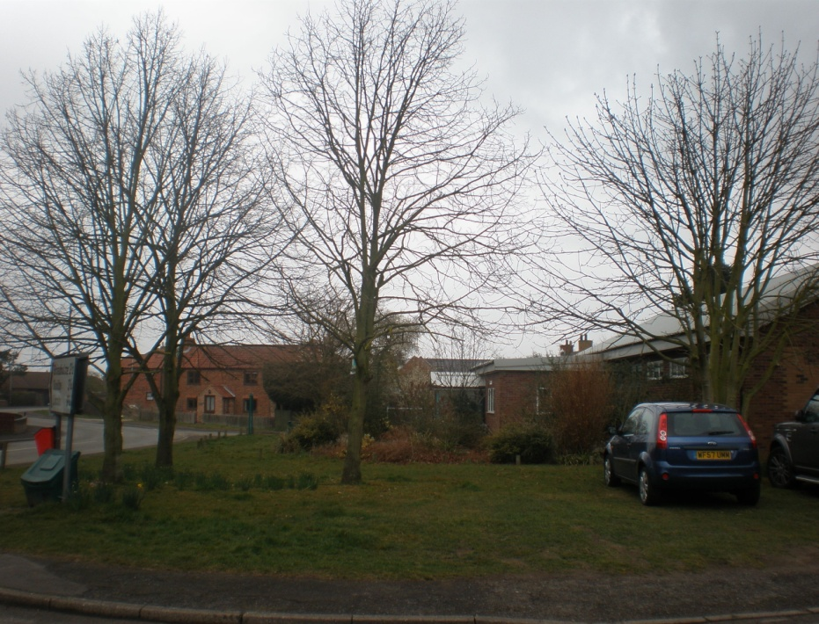

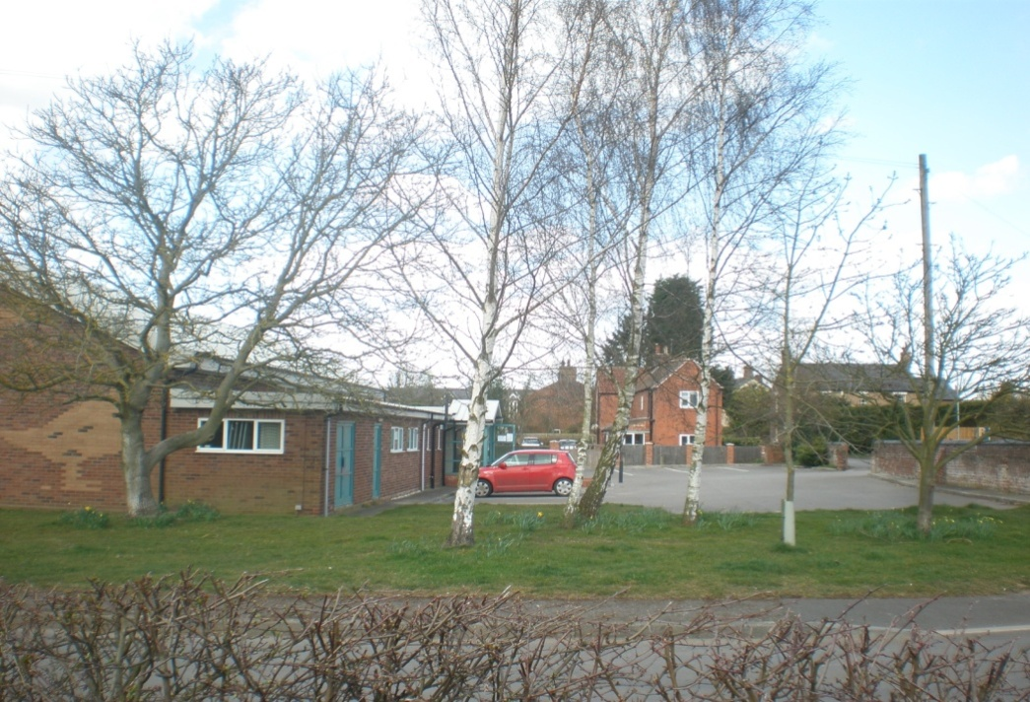

1
2
3
4
5
6
7
8
9
10
11

Image 1: Wigsley Road Trees Image 2: Wigsley Rd Trees

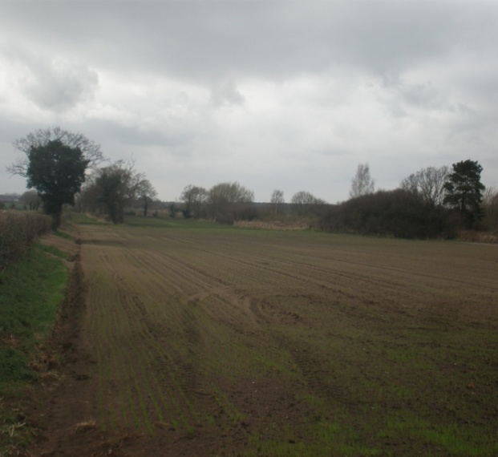
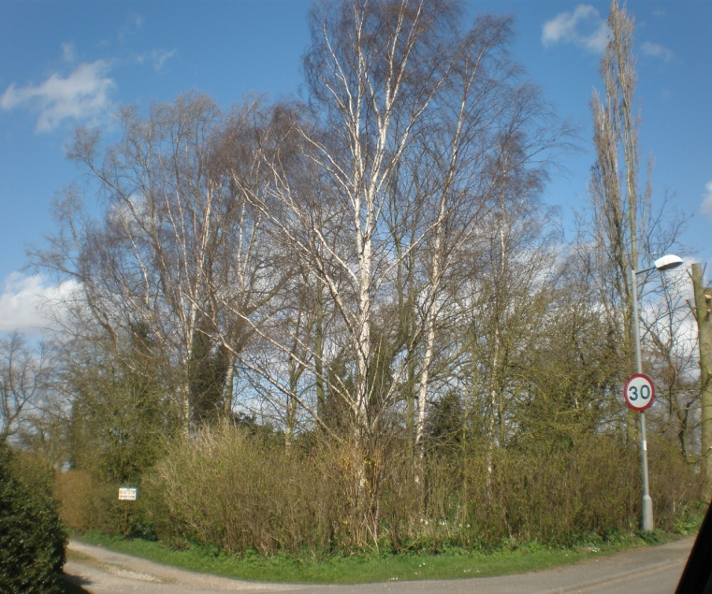
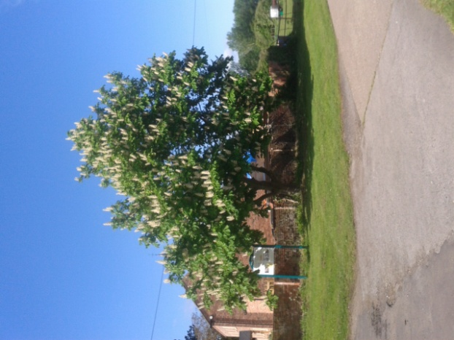
Image 3: Church Road Trees Image 4: Jowett’s Wood, Wigsley Road Image 5: Station Road Field

