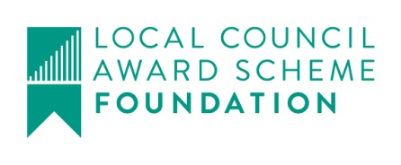
vHarby Parish Council
?

Clerk@HarbyParishCouncil.gov.uk

www.HarbyParishCouncil.gov.uk

Clerk: Yvonne Colverson 25 March 2026
NOTICE OF ORDINARY MEETING OF HARBY PARISH COUNCIL
I hereby give you notice that the Parish Council Meeting will be held at HARBY VILLAGE HALL. High Street, Harby, NG23 7EW, in the Committee Room on THURSDAY 2nd April 2026 at 19:30.

Meeting Ref: 215/26
- Declaration of intent to record, film or photograph the meeting by members, members of the public or the press
- Apologies for absence – To receive apologies for absence and approve if appropriate
3 Declaration of interests – To receive declarations of interests under consideration on this agenda in accordance with the Localism Act 2011 s.32 and The Relevant Authorities (Disclosable Pecuniary Interests) Regulations 2012.

- 10 minutes parishioner time (members of the public may ask questions or make statements. Items not on the agenda cannot be debated but may be added to the next meeting)
- Minutes of the previous meeting. To Approve the minutes of meeting: 213/25 Ordinary Meeting held on Thursday 12th February 2026..

- Planning
  - Applications
  - Decisions

- Finance
- To receive bank reconciliation for February 2026
- Payments since last meeting for approval
- Receipts since last meeting
- Payments for approval
- Clerks and Councillors Reports – To receive reports from the Clerk and Councillors, outlining actions since 12th February 2026
- Items for consideration
Allotments – To consider and resolve clearing of allotments
- Correspondence

