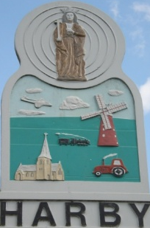
Harby Parish Council

01636 893342

Clerk@HarbyParishCouncil.gov.uk

www.HarbyParishCouncil.gov.uk

Clerk: Yvonne Colverson 25 March 2026

NOTICE OF THE ANNUAL PARISH MEETING OF HARBY

The Annual Parish Meeting will be held at HARBY VILLAGE HALL in the Committee Room on Thursday 27th March 2025 at 7.00pm. You are invited to attend.

Annual Parish Meeting Ref 214/26
214/26/1 Apologies for absence
214/26/2 To receive the Minutes of the Annual Parish Meeting of 27 March 2025
214/26/3 Chair’s report on Parish Events
214/26/4 Provisional Draft Governance Statement and financial report for the year 2025/26
214/26/5 Open forum for parishioners’ comments and questions
214/26/6 Representatives of groups within the Parish to report on progress in the last year and plans for the future
214/26/7 Collection of allotment rents

Signed: Caroline Nolan
Chairman

